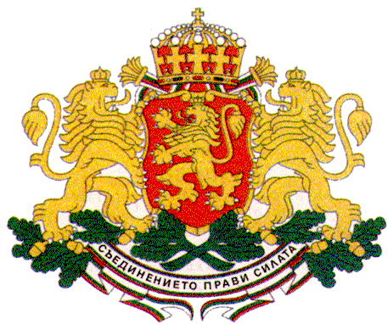 | PERMANENT MISSION OF THE REPUBLIC OF  BULGARIA  TO THE UNITED NATIONS

11 East 84th Street, New York, NY 10028, Tel: (212) 737 4790, Fax: (212) 472 9865, e-mail: bulgaria@un.int

ECOSOC High-level Political Forum on Sustainable Development, UNHQs, New York, 10 - 19 July 2017

Bringing Awareness and Action on the SDGs to the Classroom: A Presentation of Students’ Experience with the World’s Largest Lesson Exploring SDGs 2 (Zero Hunger) and 3 (Good Health)

New York, 14 July 2017, 1.15 pm to 2.30 pm, UNICEF House

H.E. Mr. Georgi Panayotov, Permanent Representative of Bulgaria to the UN

Opening Remarks

Excellencies,
Distinguished guests,
The Governments of Bulgaria, Argentina and Malaysia in partnership with UNICEF, the World’s Largest Lesson and Nord Anglia Education are happy to welcome you today to our joint event in the framework of the ECOSOC High-level Political Forum that will focus on child participation in the implementation of the 2030 Agenda for Sustainable Development and achieving the SDGs.
Our countries - Bulgaria, Argentina and Malaysia - have been strongly advocating for bringing awareness and action on the SDGs to the classroom and for empowering children to be the real agents of change for creating a more sustainable future for all.
The three countries have been actively participating in the World’s Largest Lesson Global Initiative aimed at teaching children about the SDGs since it was launched in 2015. This initiative, which has already mobilized more than 500 million girls and boys in over 160 countries has become a powerful movement to engage children in the joint effort to achieve the new goals by encouraging them to drive real change in their own lives.
###
Bulgaria believes that child participation and empowerment through education are crucial for achieving sustainable development and has been actively promoting a rights-based approach in the implementation of the 2030 Agenda ensuring quality and inclusive education for all.
As co-chair of the Group of Friends of Children and the SDGs Bulgaria has been strongly advocating for integrating children’s rights in the 2030 Agenda and for engaging children in the implementation of the Agenda by acquainting them with the SDGs in schools. Up to date more than 40 000 students in over 1 500 schools in Bulgaria have learned about the SDGs in the framework of the World’s Largest Lesson initiative and in 2016 the Government of Bulgaria adopted a new law which provides for integrating knowledge on sustainable development in the curriculum.
Thank you!

